- SIMPSON’S 1/3 RULE
AIM: AIM: TO WRITE A PROGRAM IN PYTHON TO DEMONSTRATE SIMPSON’S 1/3 RULE.
PROGRAM:
# Simpson's 1/3 Rule for I = ∫(0 to 1) e^(-x^2) dx with n = 4
import math

# Define the function
def f(x):
return math.exp(-x**2)

# Given values
a = 0 # lower limit
b = 1 # upper limit
n = 4 # number of subintervals (must be even)

# Step size
h = (b - a) / n

# Generate x and f(x) values
x = [a + i * h for i in range(n + 1)]
f_values = [f(xi) for xi in x]

# Display table
print("--------------------------------------------------")
print(" i | x(i) | f(x(i)) = e^(-x^2)")
print("--------------------------------------------------")

SIWS COLLEGE PRACTICAL NO 6

for i in range(n + 1):
print(f"{i:<3} | {x[i]:<8.4f} | {f_values[i]:<10.6f}")
print("--------------------------------------------------")

# Simpson's 1/3 rule computation
sum_odd = sum(f_values[i] for i in range(1, n, 2))
sum_even = sum(f_values[i] for i in range(2, n, 2))
I = (h / 3) * (f_values[0] + 4 * sum_odd + 2 * sum_even + f_values[-1])

# Show steps
print(f"\nh = (b - a) / n = ({b} - {a}) / {n} = {h}")
print("\nUsing Simpson's 1/3 Rule:")
print(f"I = (h/3) * [f(x0) + 4*(f(x1) + f(x3) + ...) + 2*(f(x2) + f(x4) + ...) + f(xn)]")
print(f"I = ({h}/3) * [{f_values[0]:.6f} + 4*{{{sum_odd:.6f}}} + 2*{{{sum_even:.6f}}} + {f_values[-1]:.6f}]")

# Display final result
print("\n--------------------------------------------------")
print(f"Approximate value of the integral I = {I:.6f}")
print("--------------------------------------------------")

SIWS COLLEGE PRACTICAL NO 6

OUTPUT:
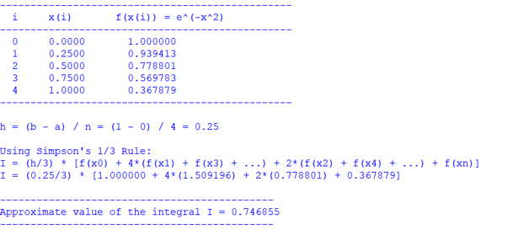
CONCLUSION: THE ABOVE PROGRAM HAS BEEN EXECUTED SUCCESSFULLY.

SIWS COLLEGE PRACTICAL NO 6

